**Project Proposal**

**On**

**KNOW MORE**



**Module: STW302CEM Agile Development**

**Softwarica College of IT and E-Commerce**

**Submitted By**: **Submitted to:**

Sanju Maharjan Model Leader: Pratik Bhusal

Manisha Basukala

Ruby Kakshapati

Bibek Yadav

Supriya Karki

Table of Contents

Abstract 3

Introduction 3

Aim: 4

Objectives 4

What is the problem the group tries to address? 4

The proposed solution: 4

Features of the project 4

Development Methodology 5

Agile Software Development 5

Why Agile software development? 5

Technologies 6

Conclusion 6

Prototype 7

References 20

# Abstract

The process of creating the e-Learning Platform that will support the online modules is described in this document. This eLearning platform was created by adding more support to an already existing learning platform and personalizing it. In this document, the function of the e-Learning Platform is explained, the requirements for the e-Learning Platform are gathered, the technical choices made during the development of the e-Learning Platform are motivated and justified, the software architecture is described, a prototype is developed, and the main use cases for the developed Platform are illustrated.

# Introduction

With the rapid advancement in science and technology, online learning plays an important role in a connected and dynamic society. The **“KNOWMORE”** project is a web-based application which is developed using Django. The overall goal of this project is to enhance users to experience quality asynchronous e-learning platform.

KnowMore is an online learning marketplace with several key features, including user authentication. In this system, there are three types of users: students who will purchase and read courses, instructors who will create courses and sell them on the marketplace, and administrators who will track and review the actions taken by students and instructors. Backend development is created with Django, a Python framework, and frontend development is done with Bootstrap 4 and Semantic UI. In addition, the Django rest framework is used to create an API, which was essential for the course builder to function. Also, Jquery, AJAX, and Sweet Alert Javascript libraries are used.

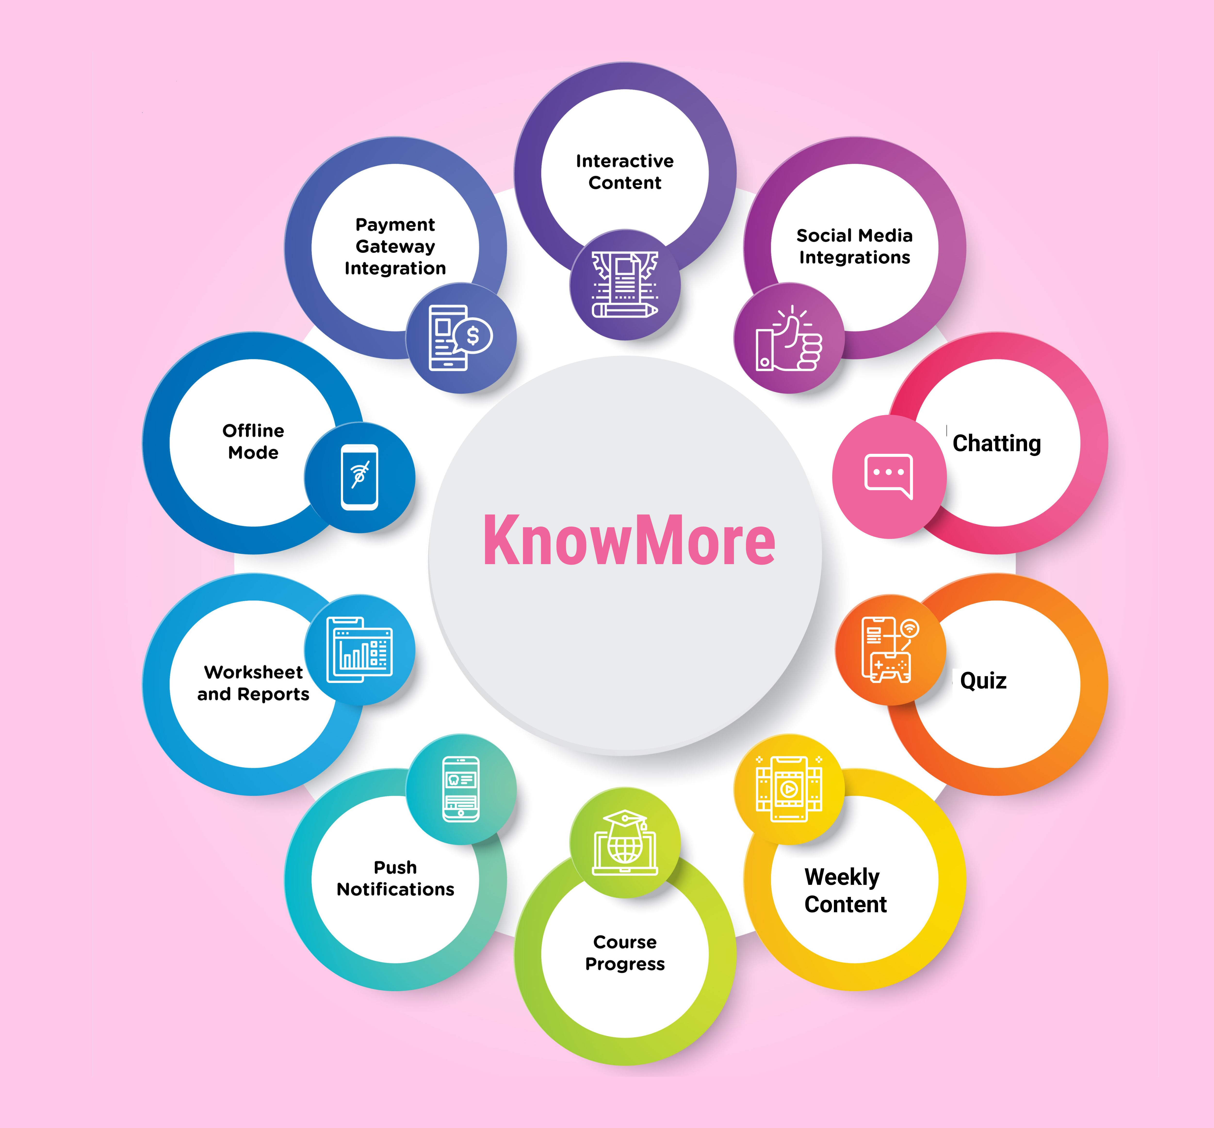

# Aim:

Create an online learning platform to assist students to learn about different subjects while also providing a platform for instructors to profit from their expertise

# Objectives

* Improve the quality of education and learning.
* Identify security risk related to e-learning website
* Enhance time flexibility and user accessibility to involve students in the learning process.
* Identity the concepts of agile development methodology.
* Develop user-friendly E-learning websites.

# What is the problem the group tries to address?

Globally, the Covid-19 has drastically changed the education system and also resulted in shutting down of many academia. Where many counties have adopted e-learning, Nepal lacks proper platform for code preparation. Most of the existing e-learning in Nepal have complicated modules and user-interface which can scare learners away from the course. Similarly, many platform lacks human interaction which can be frustrating for some learners and stop them from completing the course.

# The proposed solution:

In order to provide organized content, our product adopts micro learning approach that involves breaking information into learning units which also helps in tracking progress. The product also allows flexibility of time for learners to study content from anywhere around the globe via internet. In the same manner, it offers learners to have access to their instructors to ask feedback or help via communication channel such as chat or feedback panel which enhances social engagement.

# Features of the project

1. Login and registration system
2. Email verification using One Time Password (OTP).
3. Password reset using email (STMP)
4. 3 different types of users (admin, learners, Instructors)
5. Separate dashboard for student, instructor, and admin
6. Allow students to view courses, add to cart, remove from cart, and buy the course using online payment gateway such as PayPal.
7. Allow student to enroll, read course, attempt quiz content after payment.
8. Course builder
9. Allow instructor to create, view and edit courses.
10. Admin dashboard, having functionality such as view, edit and approve users and instructor. Also, admin can approve and suspend instructor and their courses

# Development Methodology

There are different development methodology: Waterfall, Agile Software Development Methodology, Spiral Model, etc. Among them, for this project Agile Software Development is most suitable development methodology.

## Agile Software Development

Agile software development -- also referred to simply as Agile -- is a type of development methodology that anticipates the need for flexibility and applies a level of pragmatism to the delivery of the finished product. Agile software development requires a cultural shift in many companies because it focuses on the clean delivery of individual pieces or parts of the software and not on the entire application.

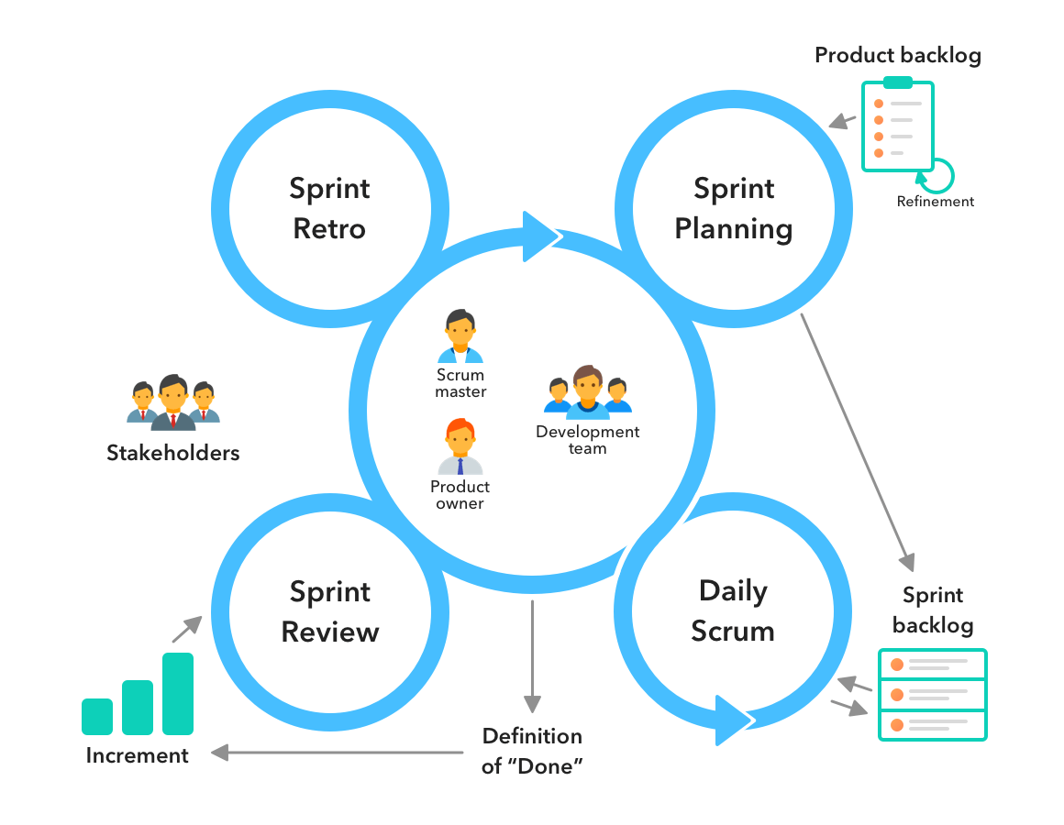

## Why Agile software development?

In this project agile software development methodology is used as there are lots of benefits of using this models.

1. It is suitable for group projects with very good understanding of specification.
2. The stages are clearly divided, so that every task can be conveniently organized.
3. By breaking down the project into manageable units, the project team can focus on high-quality development, testing, and collaboration.
4. Agile commonly uses user stories with business-focused [acceptance criteria](https://www.seguetech.com/blog/2013/03/25/characteristics-good-agile-acceptance-criteria) to define product features.
5. By using time-boxed, fixed schedule Sprints of 1-4 weeks, new features are delivered quickly and frequently, with a high level of predictability.
6. As each Sprint is a fixed duration, the cost is predictable and limited to the amount of work that can be performed by the team in the fixed-schedule time box.

# Technologies

1. HTML

HTML or Hyper Text Markup Language is a common makeup language for documents that are intended to be used in web browser. HTML is also represented as the skeleton system of a webpage.

1. CSS

CSS or Cascading Style Sheet is a basic design language used to design HTML document. CSS describe how HTML element should be displayed.

1. JavaScript

JavaScript is commonly used for creating web pages. It allows us to add dynamic behavior to the webpage and add special effects to webpage.

1. Bootstrap

Bootstrap is used to make websites responsive for all devices.

1. JQuery

JQuery is a fast, small and feature-rich JavaScript library. It makes things like HTML document traversal and manipulation, event-handling, animation and Ajax much simpler to use.

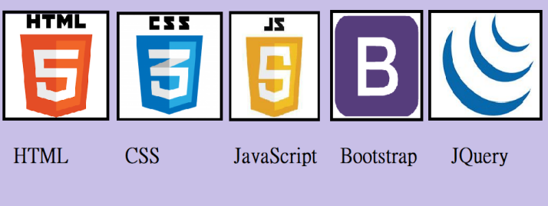

# Conclusion

E-learning involves more than just a change in technology. It is a component of redefining our knowledge and abilities. Online learning has many benefits as compared to conventional learning I would therefore recommend that online learning be implemented on all learning institutions and research on how to improve this learning process should be carried out.

# Prototype

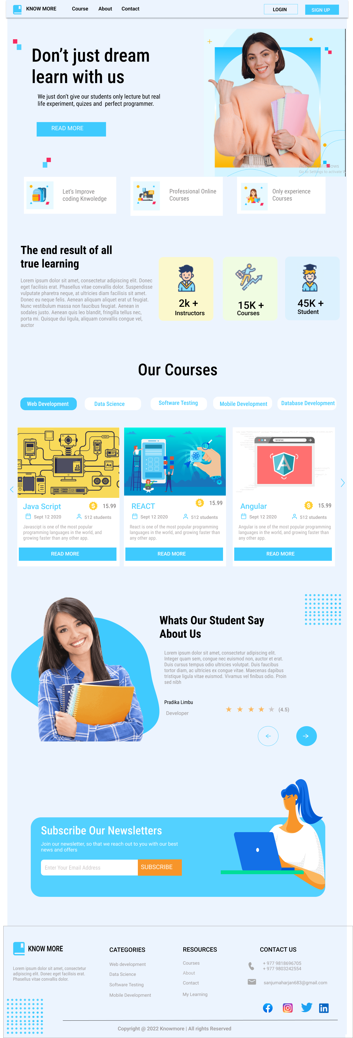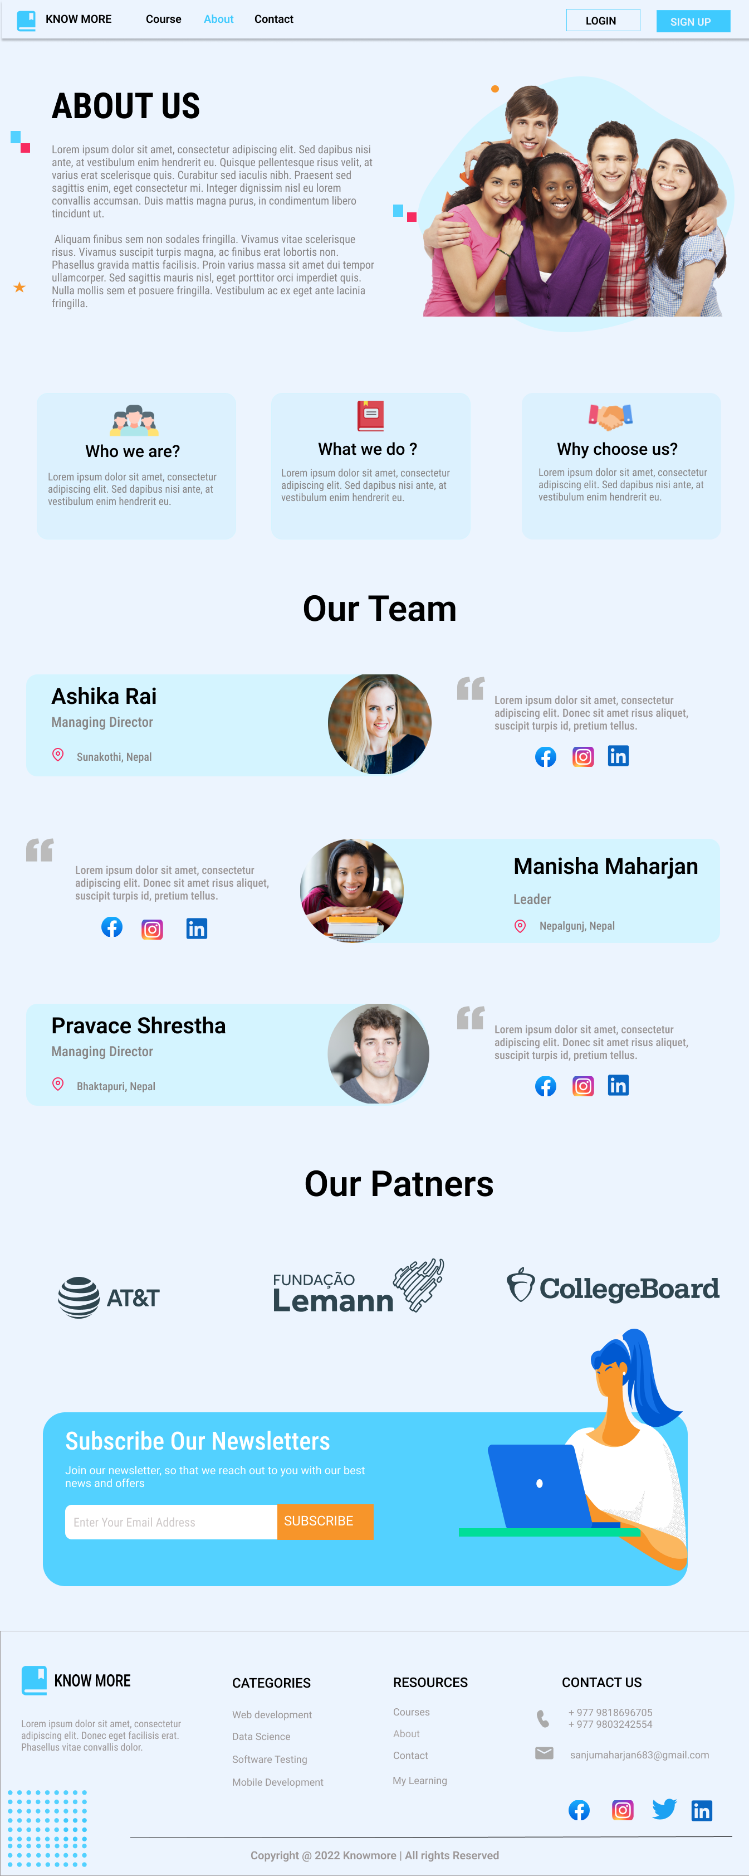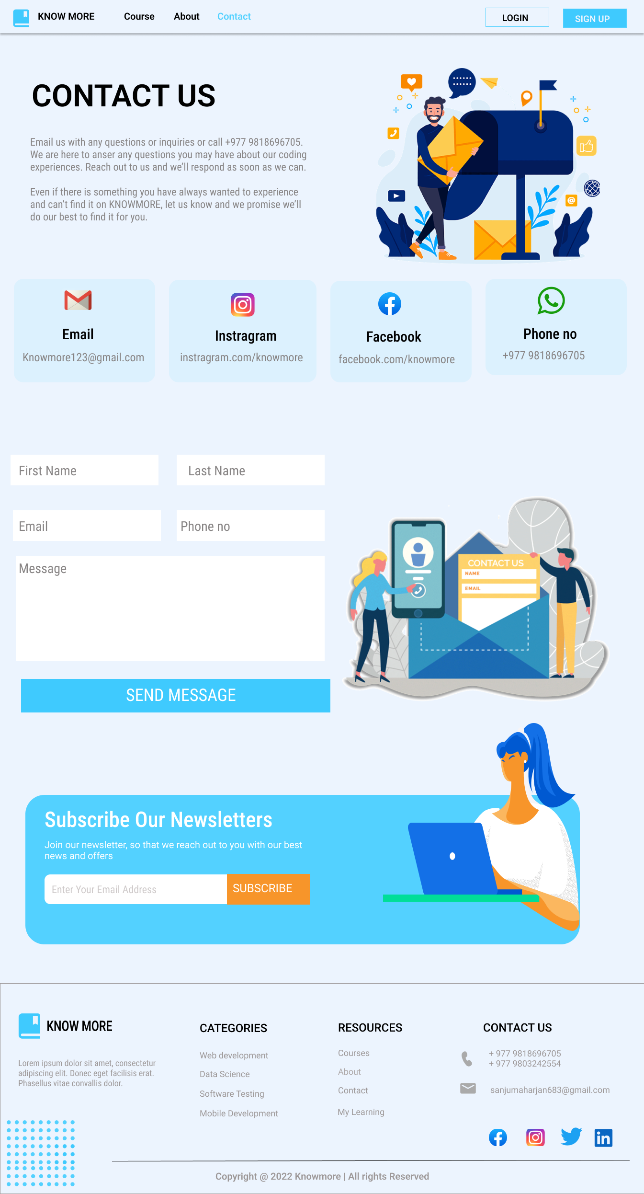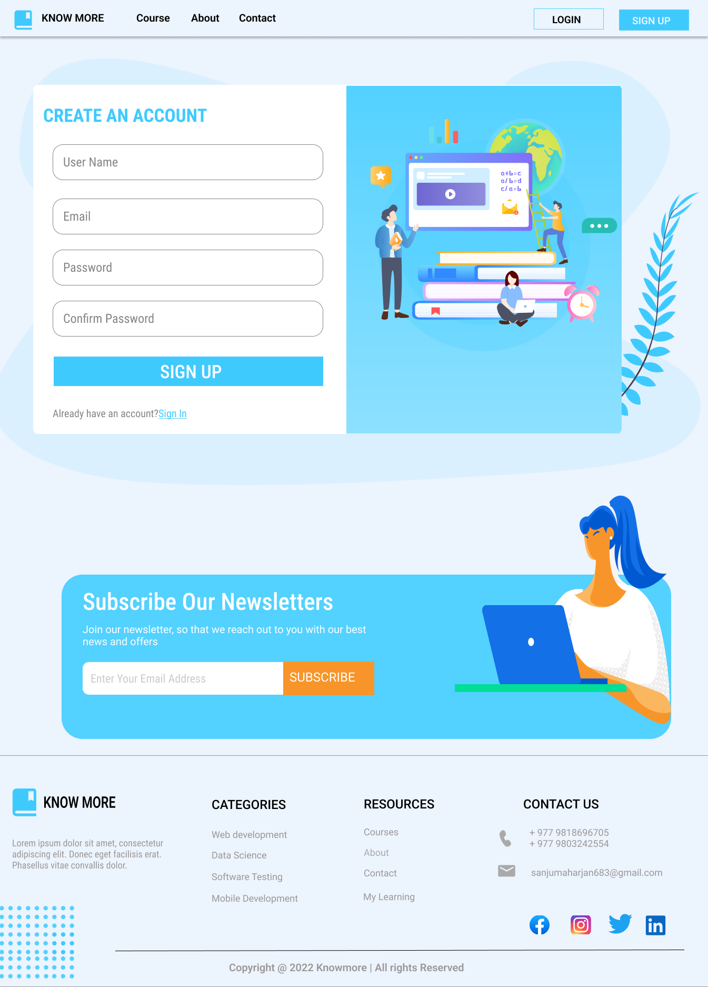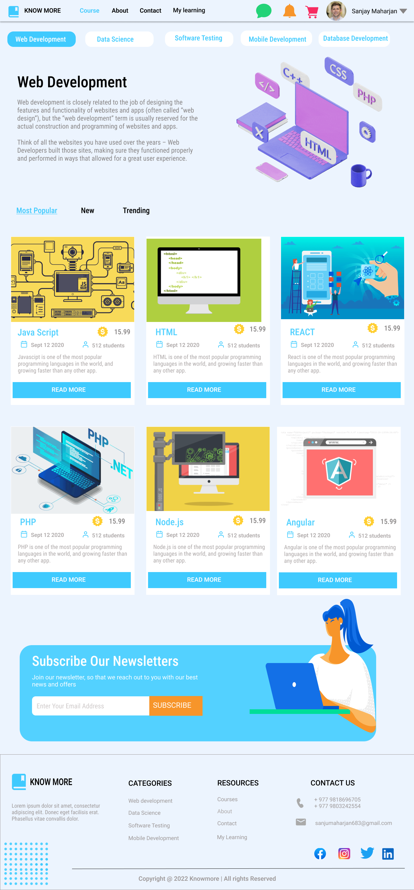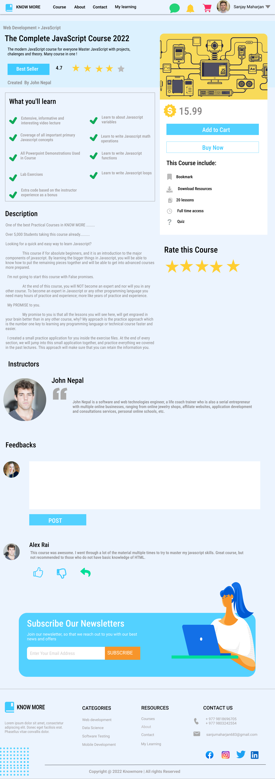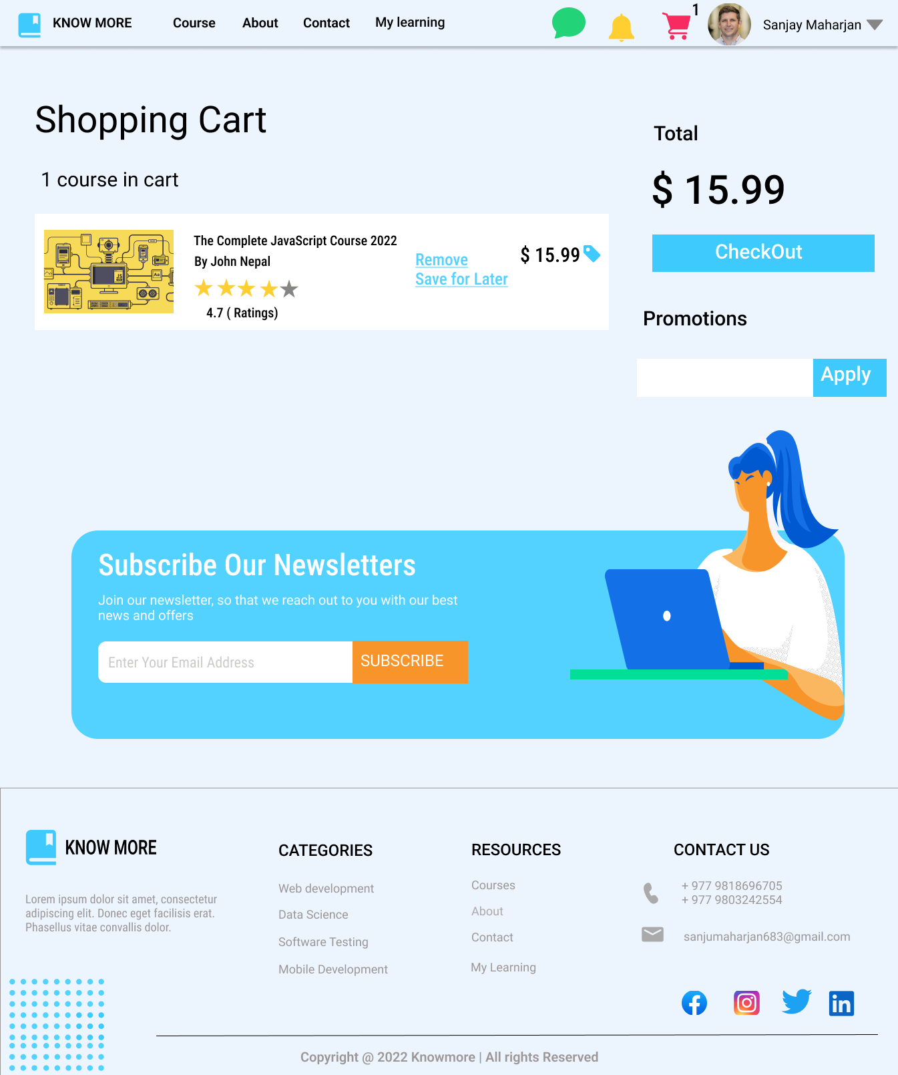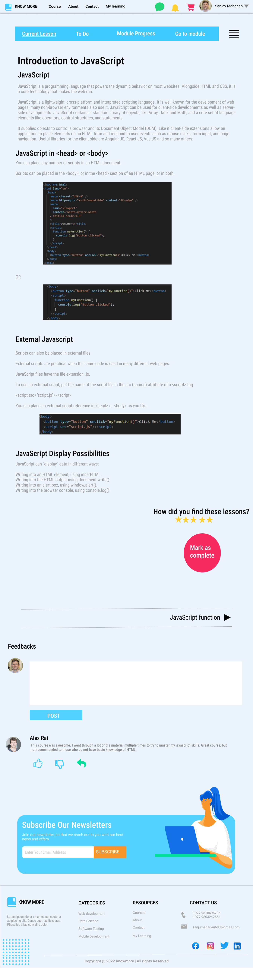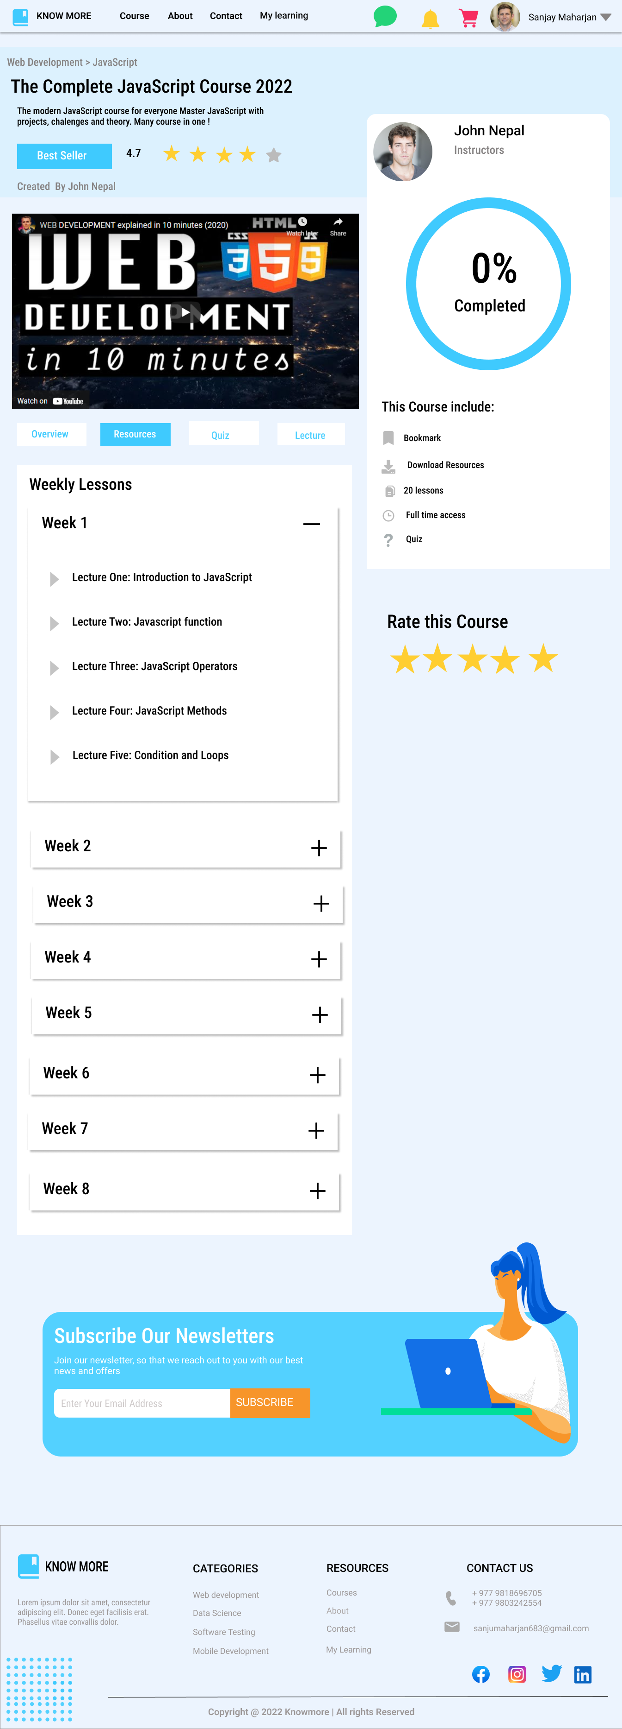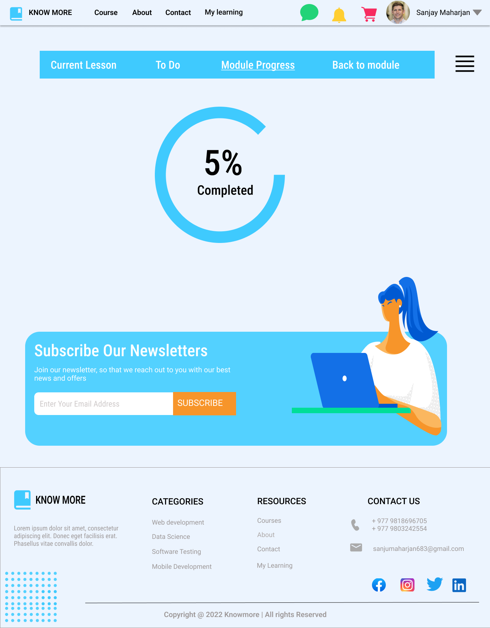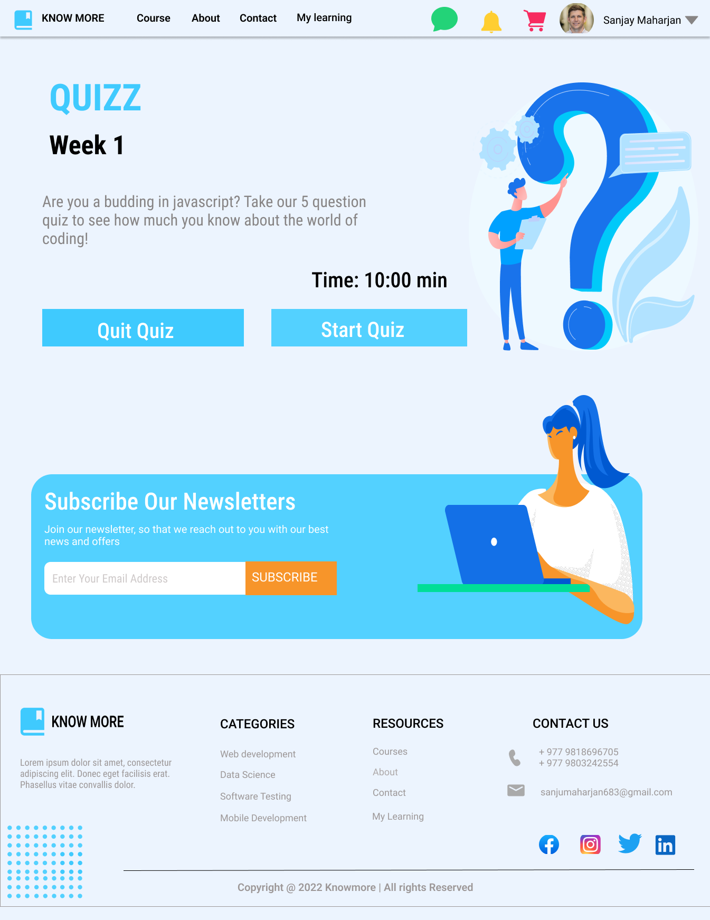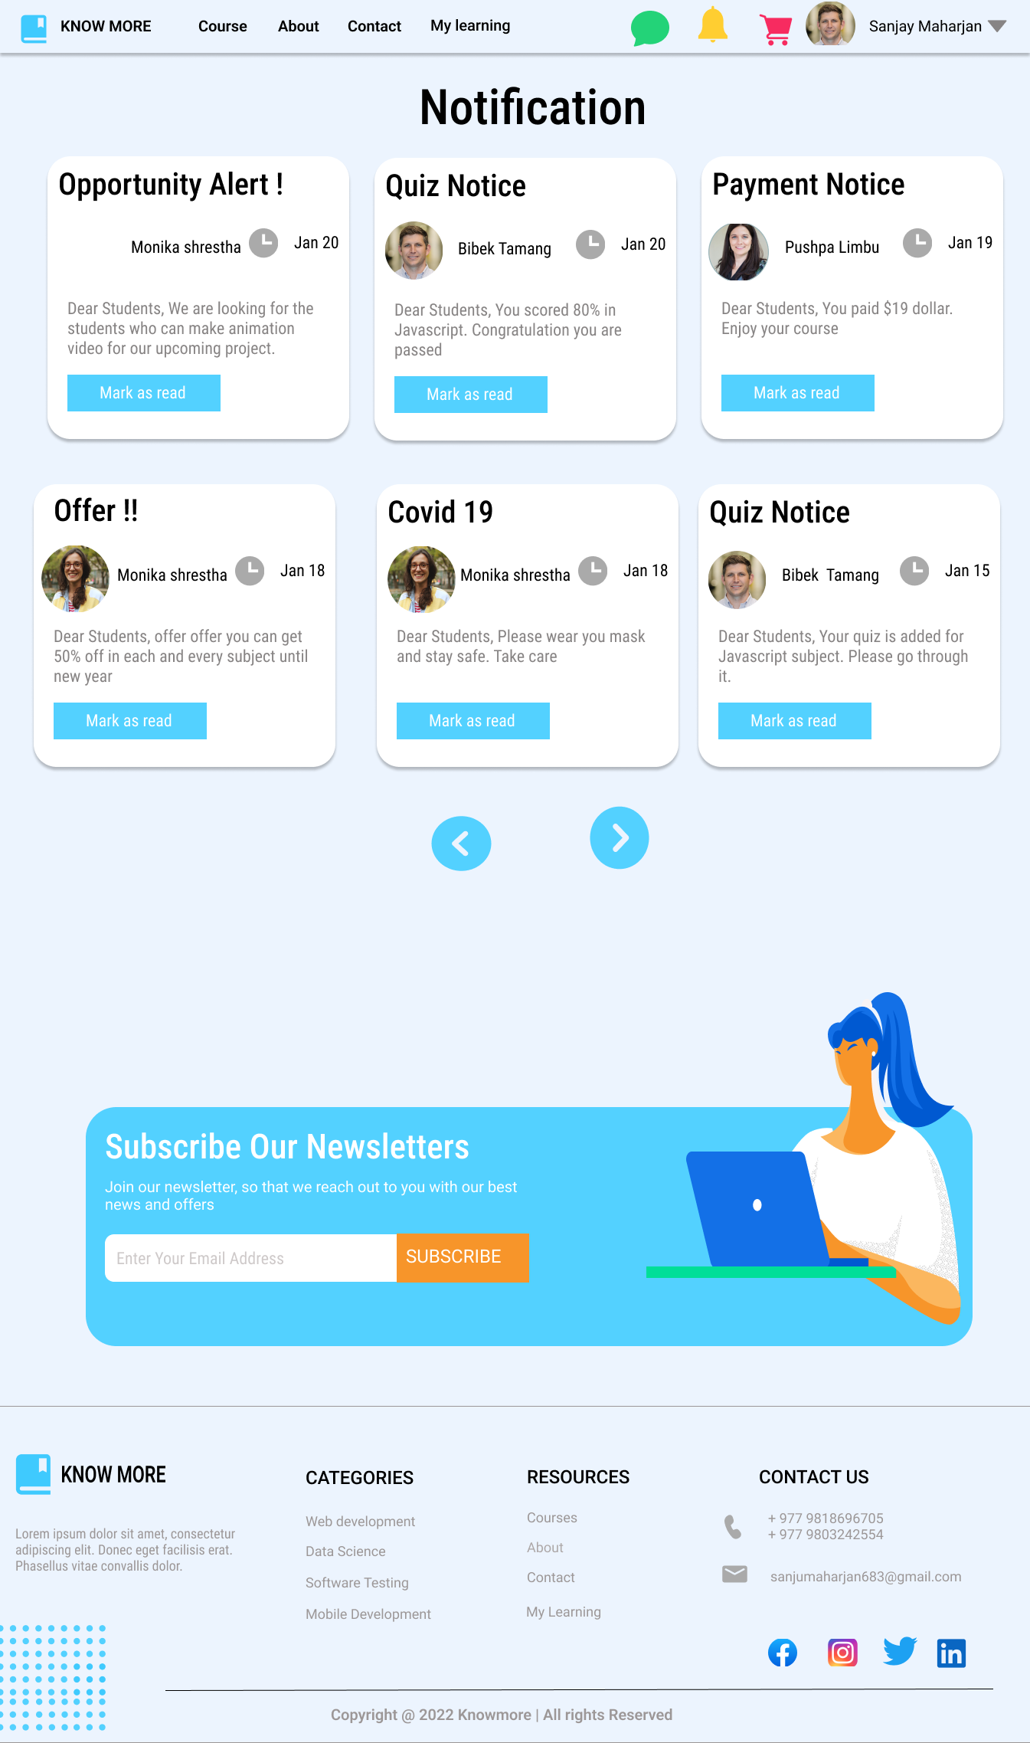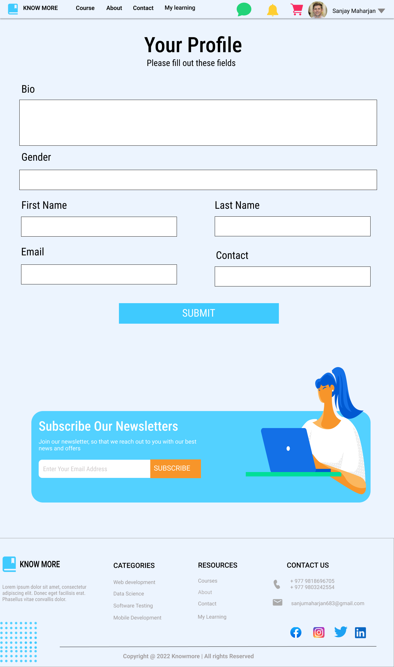

# References

Hamilton, T. (2022, 8 22). *Guru99*. Retrieved from Guru99: https://www.guru99.com/agile-scrum-extreme-testing.html

MDN. (2022, 6 13). *mdn*. Retrieved from mdn: https://developer.mozilla.org/en-US/docs/Web/HTML

(nd, nd nd). Retrieved from https://www.javatpoint.com/what-is-jquery